🡪 STACKED BAR CHARTS and SIDE-BY-SIDE BAR CHARTS

# Create **side-by-side** **barchart** of gender by alignment

ggplot(comics, aes(x = align, fill = gender)) +

geom_bar(position = “dodge”)

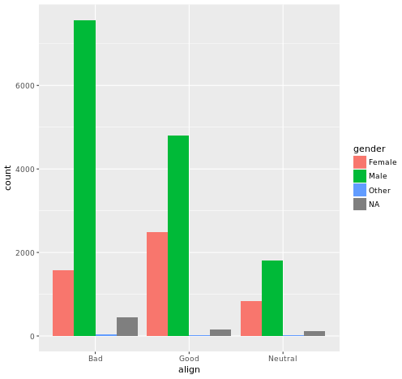

# Create **STACKED barchart** of gender by alignment

ggplot(comics, aes(x = align, fill = gender)) +

geom_bar()

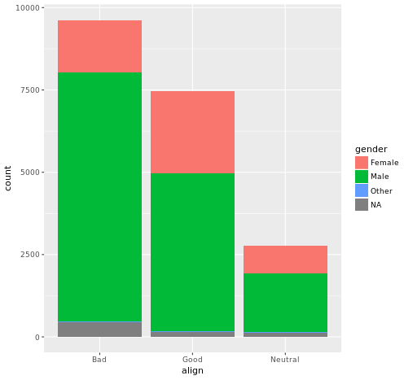

[Both align and gender variables are categorical, hence when we assign them to “x” and “fill” arguments, we get stacked bar chart.]

* counts and proportions
* Sometimes, proportions are preferred over the count of the observations.

table() --- **count** of observations of combination of variables

prop.table() -- **proportion** of observations of combination of variables

sum(prop.table()) --- is always 1.

* **Conditional proportions:**

To calculate conditional probability, write:

1. *For CONDITION on the* ***rows****: ** rows sum to 1*

Sample Code:

count_tab <- table(df$col1, df$col2)

prop.table(count_tab, **1**)

1. *For CONDITION on* ***columns****: ** columns sum to 1*

Sample Code:

count_tab <- table(df$col1, df$col2)

prop.table(count_tab, **2**)

* [Bar Chart is again a GOOD option for graphically representing proportions.]
* geom_bar should have an argument **position = ”fill”** for proportions.
* Again, “x” and “fill” aesthetics should have categorical variables assigned.
* Bar charts can tell dramatically different stories depending on whether they represent counts or proportions and, if proportions, what the proportions are conditioned on.
* Barcharts: one of counts and one of proportions.

# Plot of gender by align

ggplot(comics, aes(x = gender, fill = align)) +

geom_bar()

# Plot proportion of gender, conditional on align

ggplot(comics, aes(x = gender, fill = align)) +

geom_bar(position = "fill") +

ylab("proportion")

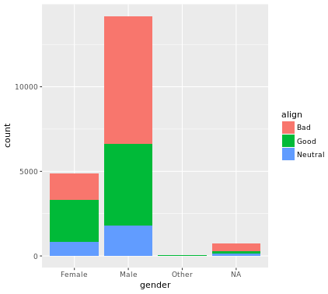 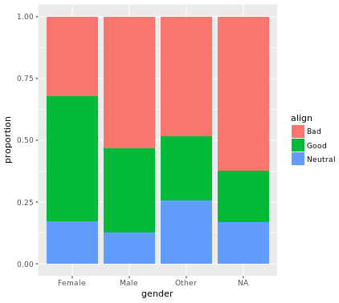

🡪 Distribution of one variable

* table(df$col)
* can be visualized using a **simple bar chart**.

ggplot(data, aes(x= col)) +

geom_bar()

* Can be visualized using **faceted bar charts.**

**[Faceting** allows the breaking of the data based on levels and forming separate bar chart for each level.]

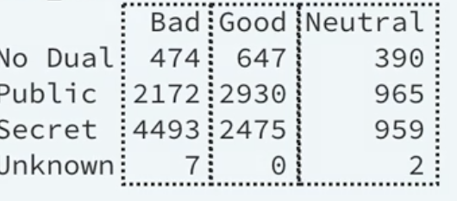

Example:

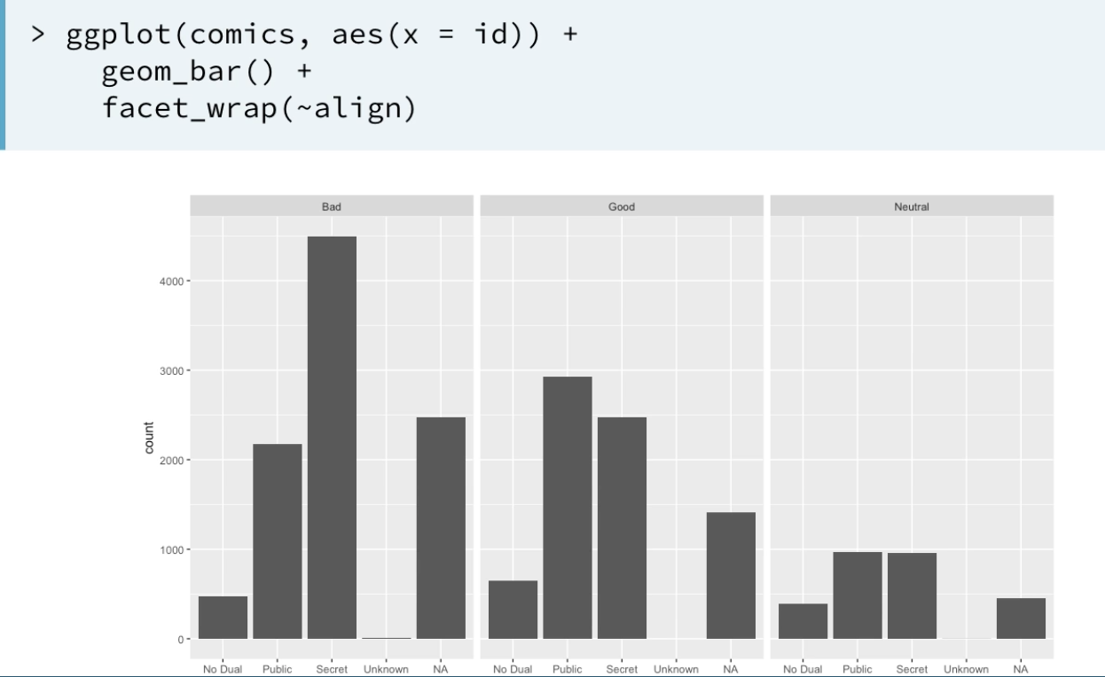

* Can be visualized using **pie charts.**

**EXPLORING NUMERIC DATA**

* str() – to understand the type of variables and then start.
* Can be visualized using **dot plot**:

ggplot(data, aes(x= weight)) +

dot_plot()

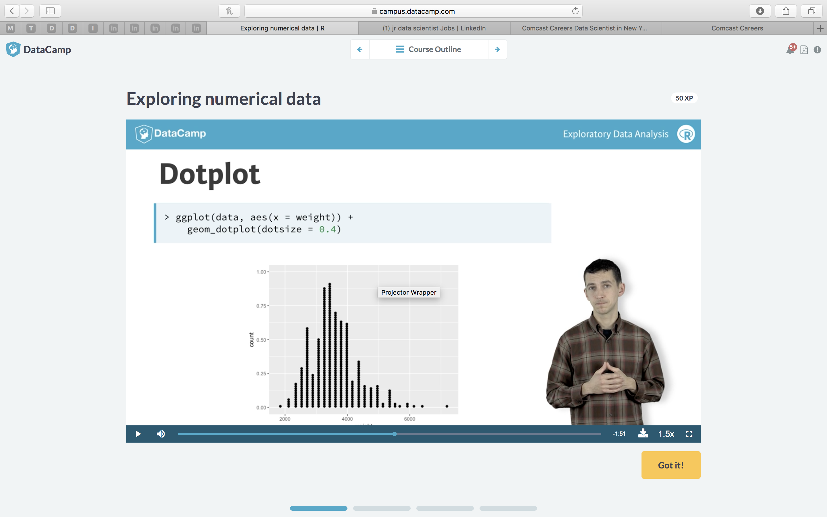

* Can be visualized using **histogram.**
* ggplot(data, aes(x= weight)) +

geom_histogram()

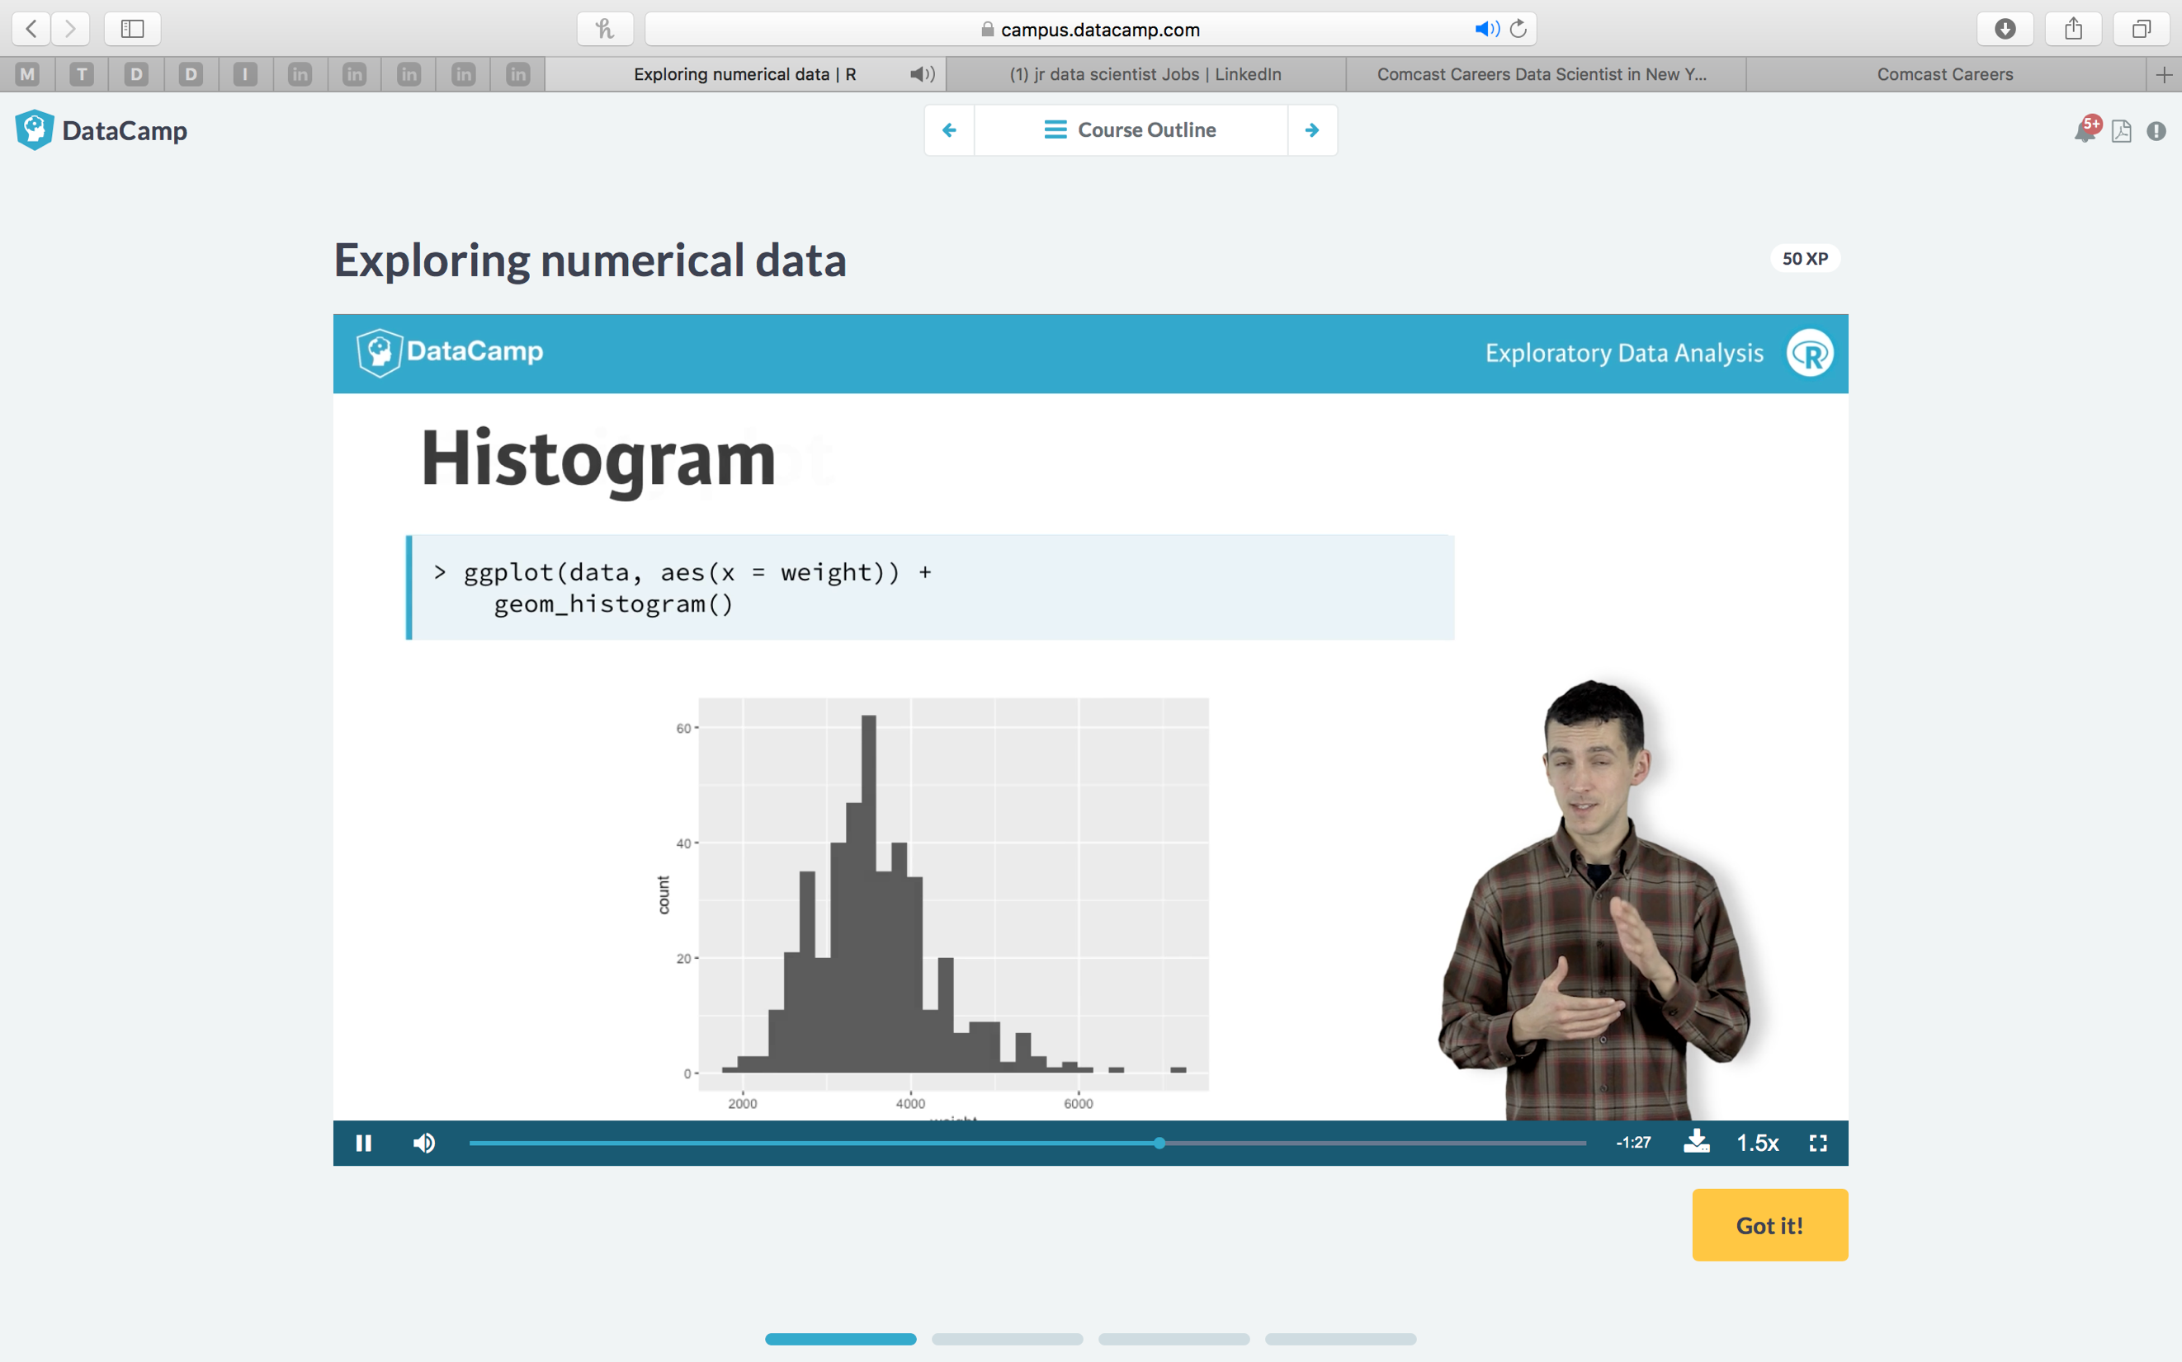

* Can be visualized using **density plot.**

**[used when there are large number of cases]**

ggplot(data, aes(x= weight)) +

geom_density()

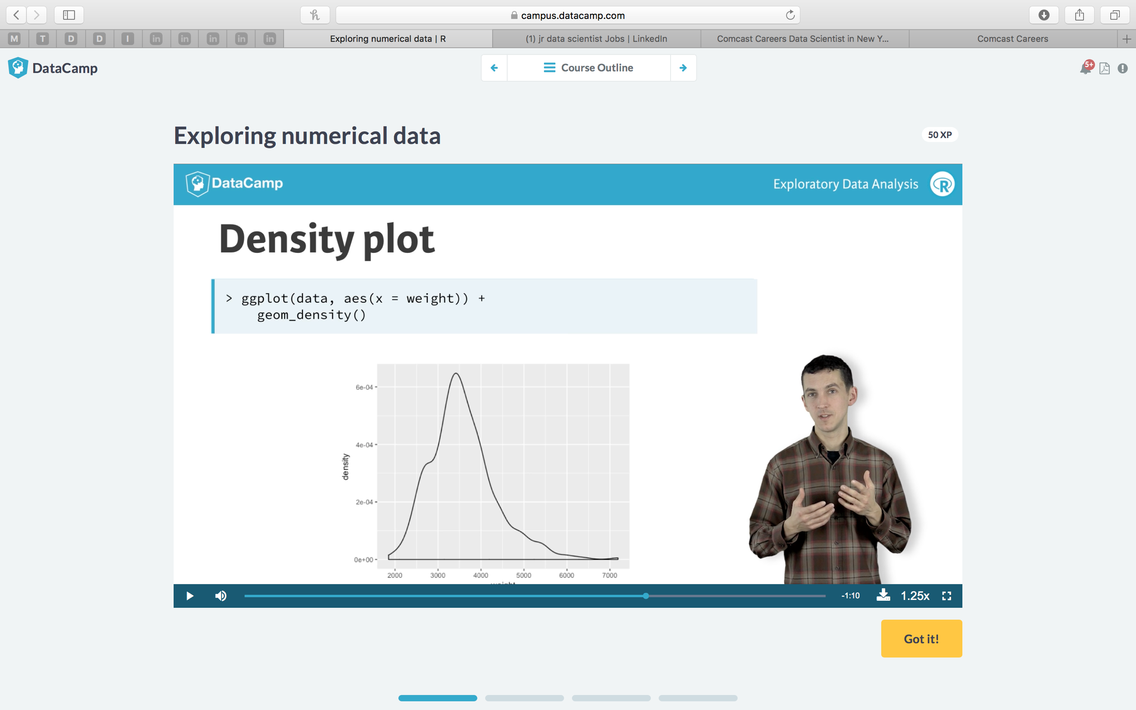

[in the density plot, we can identify the center of the distribution, the values that mark off the middle half off the data, the values that mark off the vast majority of the data.] This can be seen more clearly in a boxplot.

* Can be visualized using **boxplot.**

ggplot(data, aes(x= weight)) +

geom_boxplot() +

coord_flip()

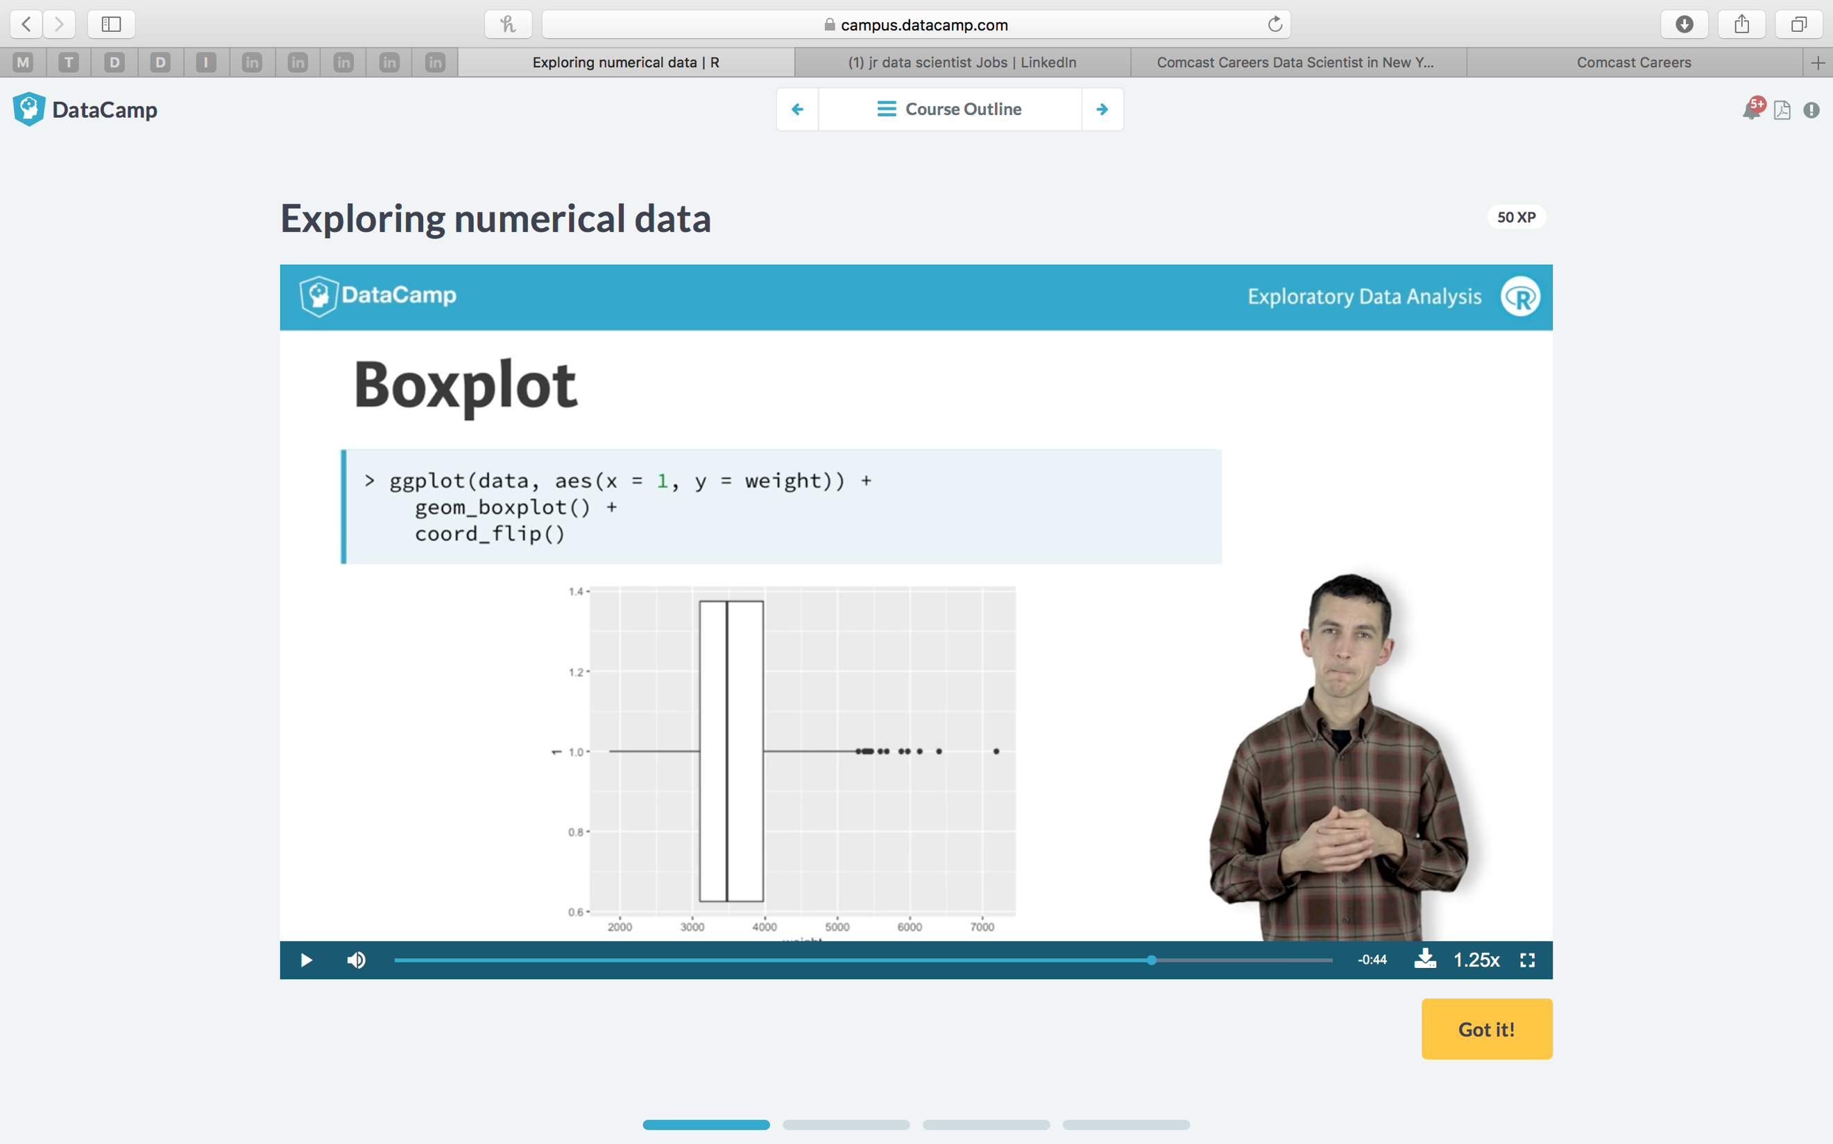

Examples:

* Create side-by-side box plots of city_mpg separated out by ncyl.

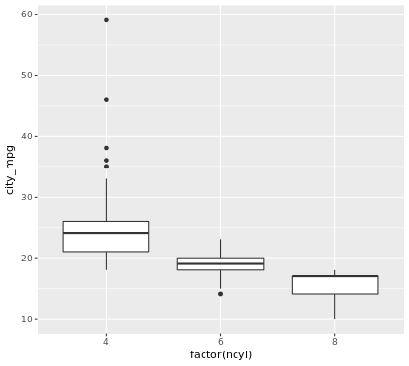

* Create overlaid density plots of city_mpg colored by ncyl.

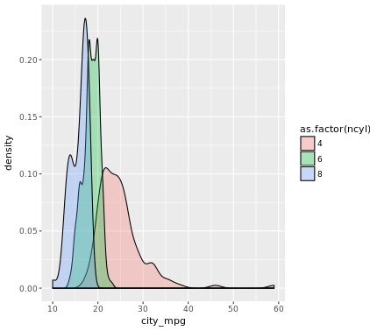

**Code for above two plots:**

**# Filter cars with 4, 6, 8 cylinders**

**common_cyl <- filter(cars, ncyl %in% c(4, 6, 8))**

**# Create box plots of city mpg by ncyl**

**ggplot(common_cyl, aes(x = as.factor(ncyl), y = city_mpg)) +**

**geom_boxplot()**

**# Create overlaid density plots for same data**

**ggplot(common_cyl, aes(x = city_mpg, fill = as.factor(ncyl))) +**

**geom_density(alpha = .3)**

**🡪 Distribution of a single variable:**

1. **Marginal distribution:**

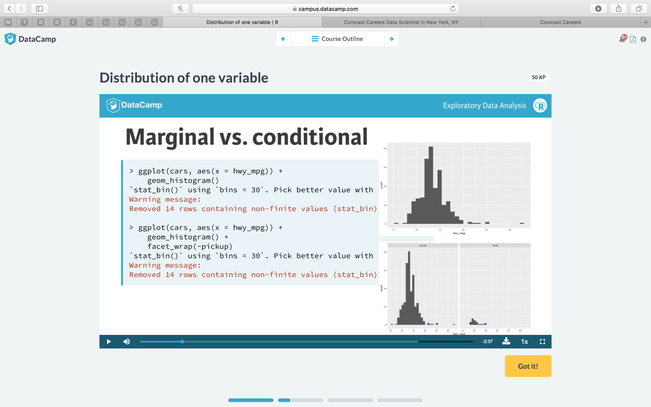

The first plot is for the distribution of the entire variable.

The second plot shows the distribution SEPARATELY for ick-ups and non-pickups.

(*These are marginal distributions)*

1. **Conditional distribution:**

🡪 Building a data pipeline:

(Cases where we have to Filter the data and then apply ggplot function to visualize it)

Here, let’s take the case of the cars with engine capacity less than 2.0.

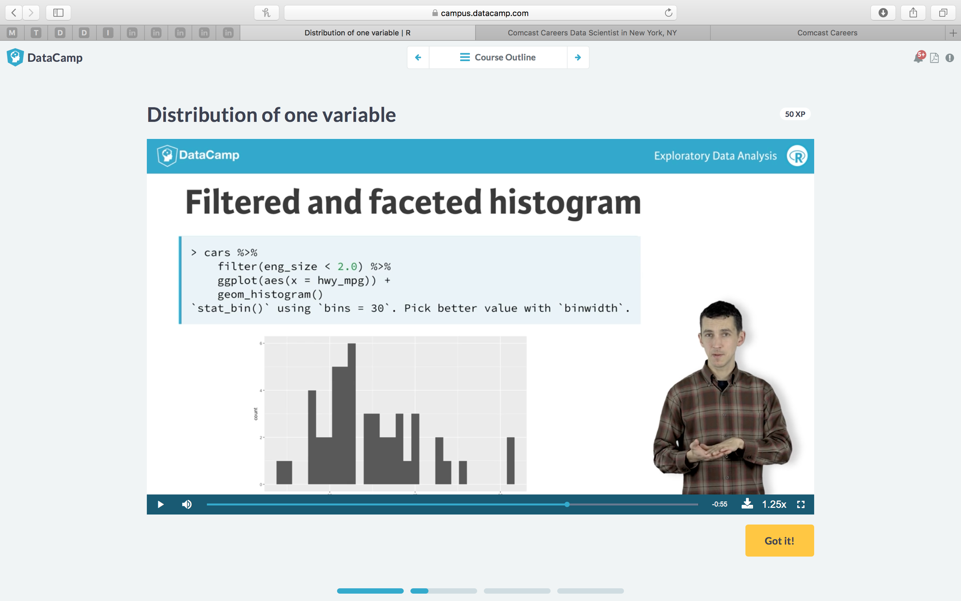

**🡪 Adjusting the “binwidth”:**

The shape of the distribution can change based on the binwidth selected.

Example 1: Selecting a WIDE binwidth for a histogram.

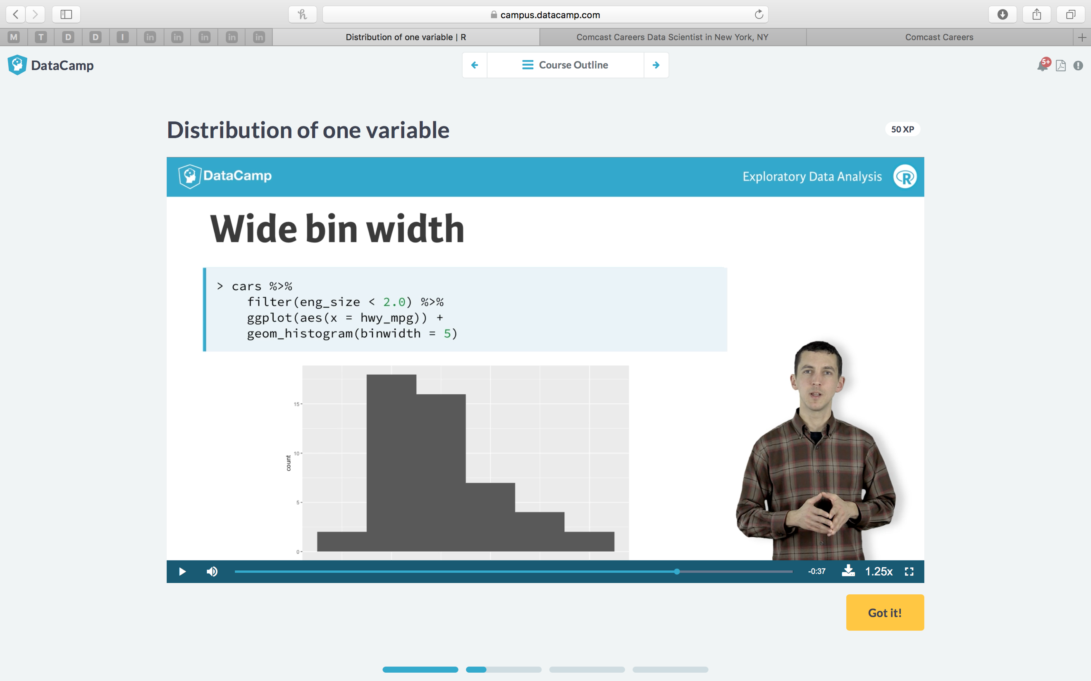

This bin width makes the plot much “smoother”.

Example 2: Selecting a WIDE binwidth for a density plot.

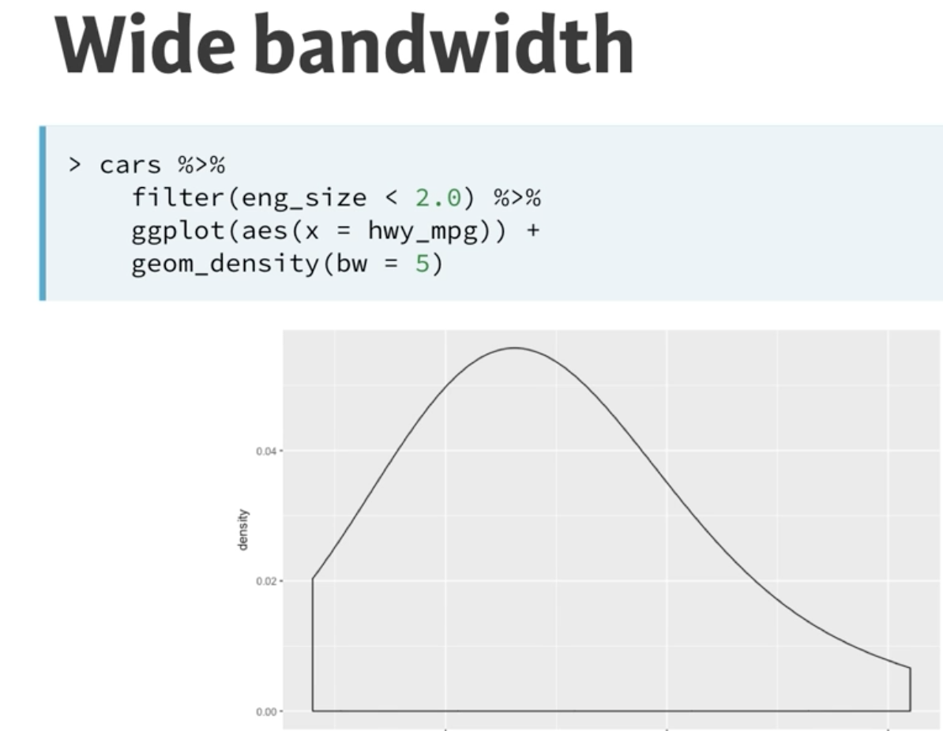

*But how do we know which is the BEST bin width for a particular plot?*

Generally, the default bin width selected by R is good. But wide bin widths give a chance for us to see the smoother versions of the plots(to see how they perform on such scales).

**🡪 BOXPLOTS**

- Boxplots are based on three summary statistics- **first , second and third quartiles.**

**- The second quartile –** Is the median*(means, half data is below this point and half data is above this point)*

- The first quartile – has 1 quarter of data below it

- The third quartile – has 3 quarters of data below it.

- So, the middle half of the data is inside this box.

- the lines that extend from the box- are called **whiskers.** They should encompass nearly all the data.

- the dots represent the **outliers.**

Example:

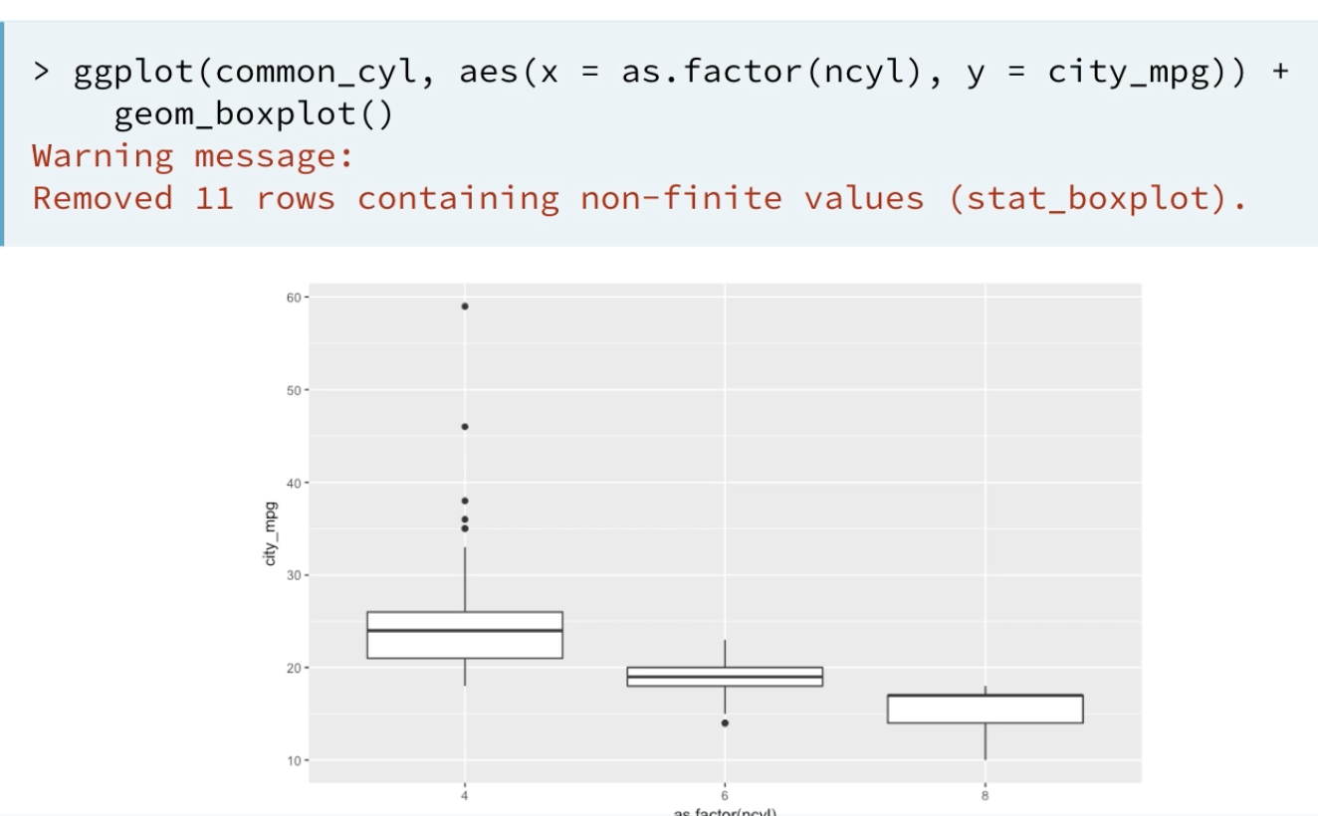

In the above boxplots, they are created separately for three categories of cylinders. (4,6,8)

Usually, they are created separately for different categories that exist.

But, if you want to create for NO categories and just want to show the distribution for a continuous variable( here, city_mpg), then initiate the “x” aesthetic value of ggplot to 1.

***When are boxplots useful??***

When you want to:

1. **Show several distributions** (of the categories(levels)) **of a factor at once**.
2. To see the outliers.

***Weaknesses of boxplots?***

**No capacity** to indicate whether the distribution has more than one hump or **MODEs.**

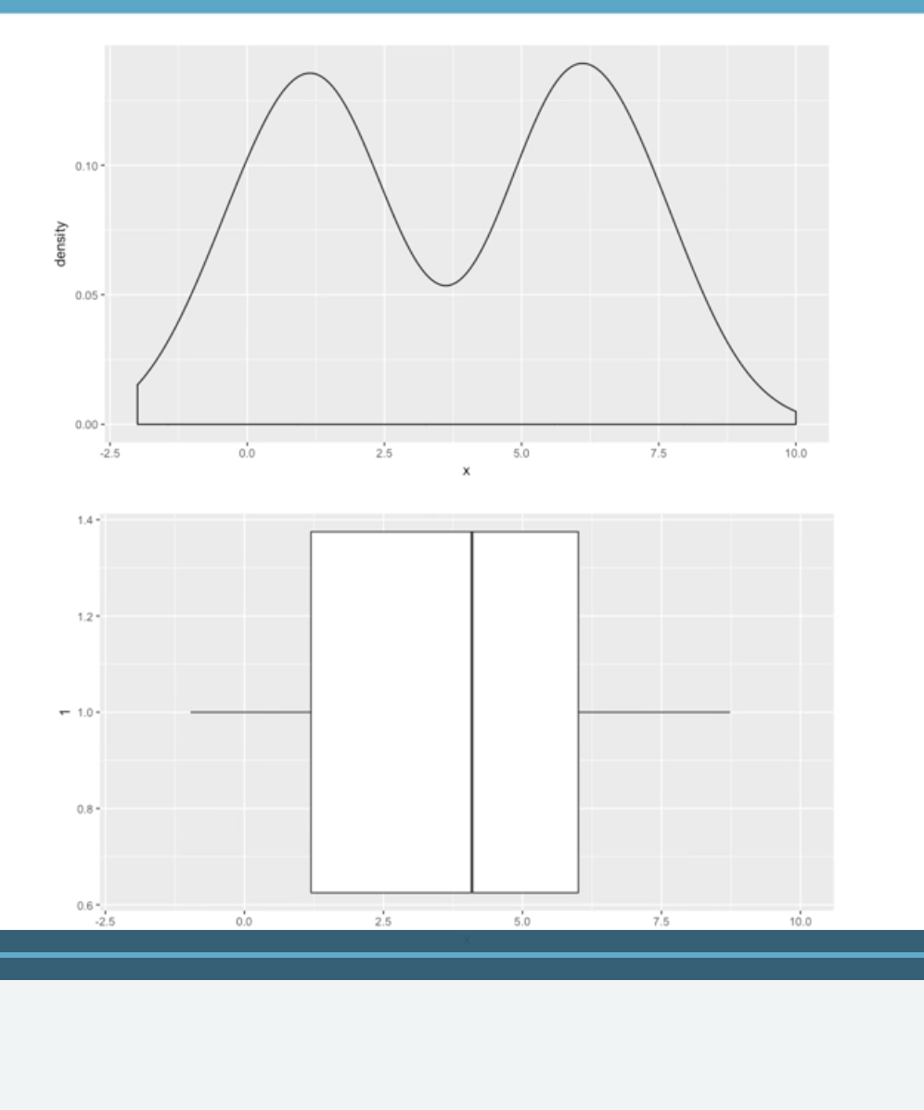

* Sometimes, density plots are not a good way to interpret data.

for example, when we take a three variable plotting using density plot as shown:

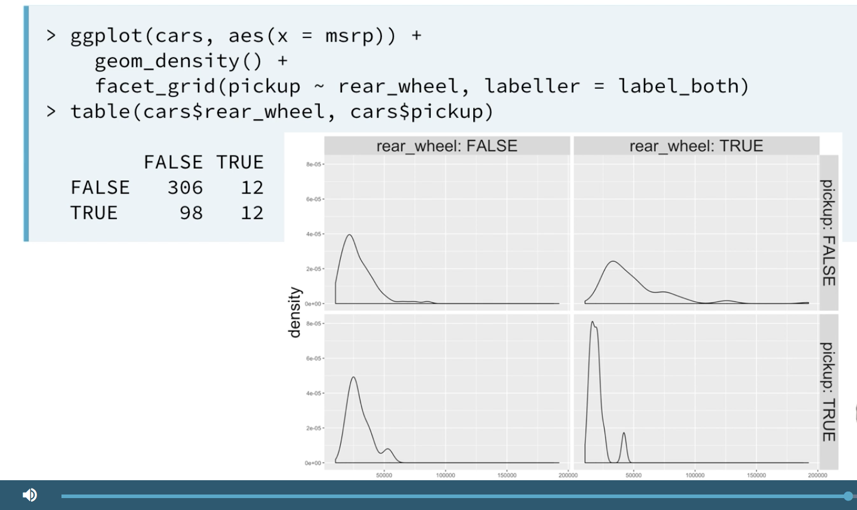

Since, the density plot normalizes the distribution to make the areas same, the distribution of the variable looks same even though it is significantly DIFFERENT.

Please be careful while selecting the plots. ☺

🡪 **Three variable plots**

This can be done using faceting.

But again, carefully observe how it must be done for various plots:

**Plot 1: 3 variable plot using “boxplot” :**

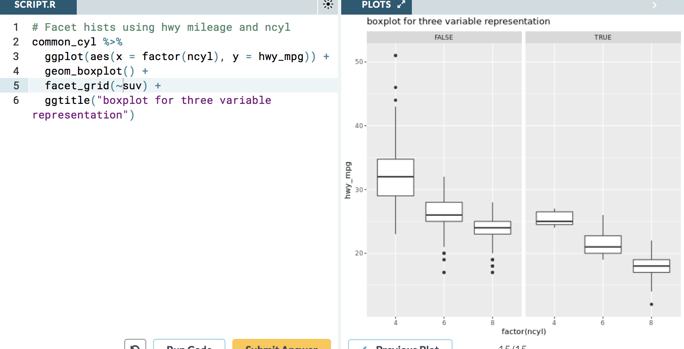

**Plot 2: 3 variable plot using “histogram” :**

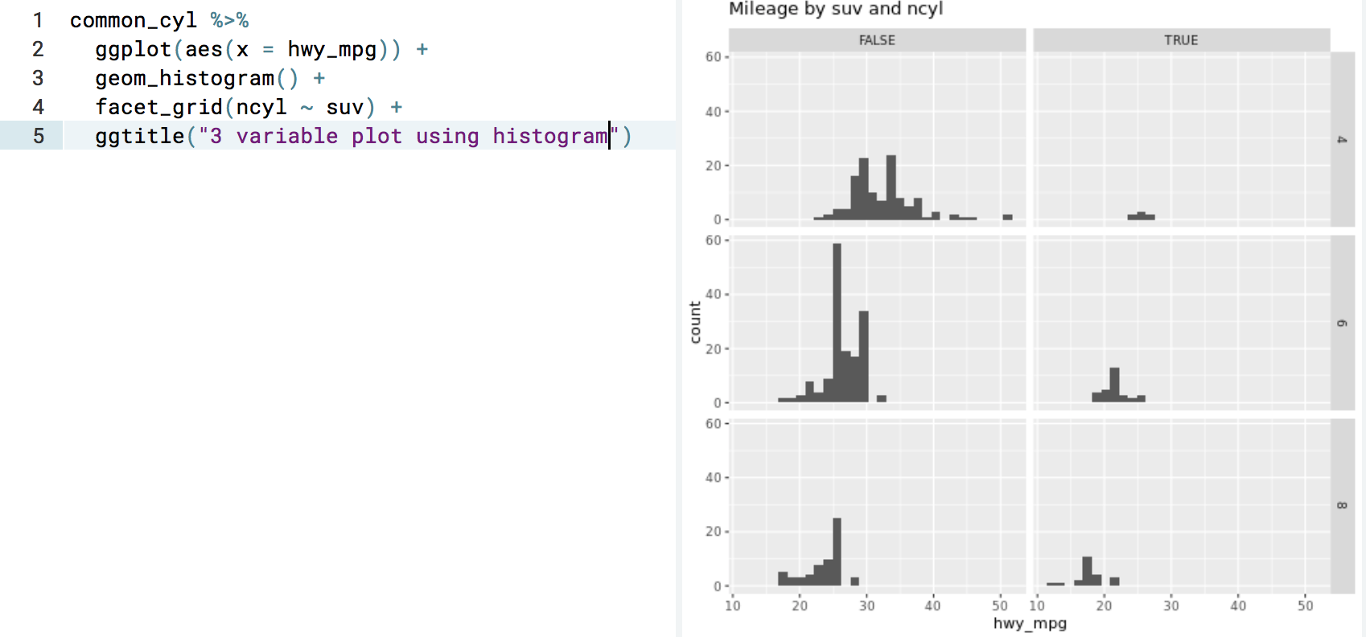

Observe that there is difference in the code for different plots ☺

**NUMERICAL SUMMARIES**

1. **Measures of tendency:**
2. **Mean**

sum of observations / number of observations.

Balance point of the data.

Tends to be drawn towards the longer tail of distribution. (Because of its sensitivity towards extreme values)

mean()

1. **Median:**

Middle value in the data.

Median divides the data into lower and upper halves.

1. **Mode:**

Most common observation in the data.

median()

table() – and see which has the highest numbe of observations.

* group_by()

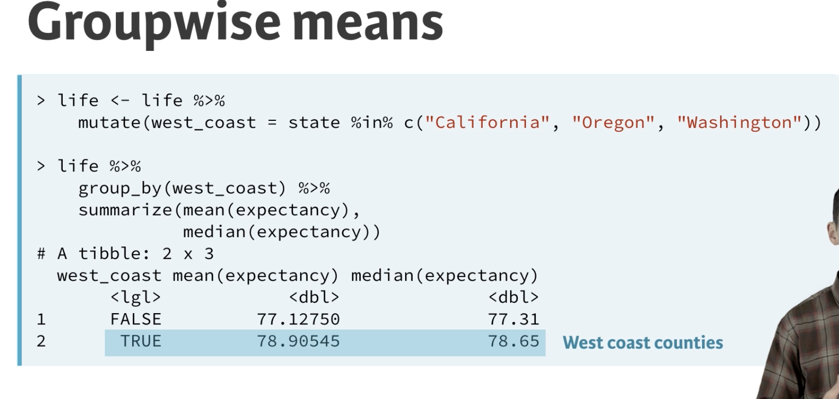

* Without group_by()—**using slice()**

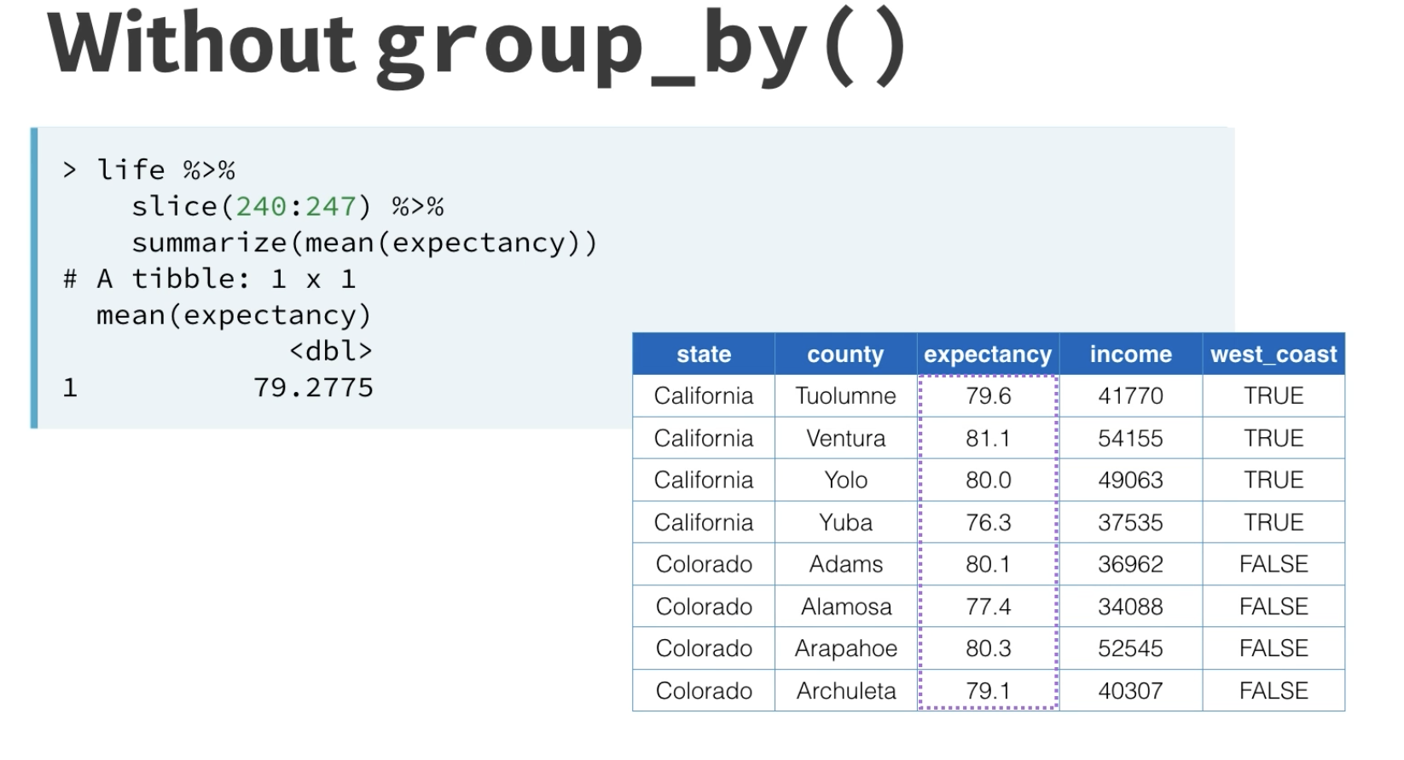

* With slice() and group_by():

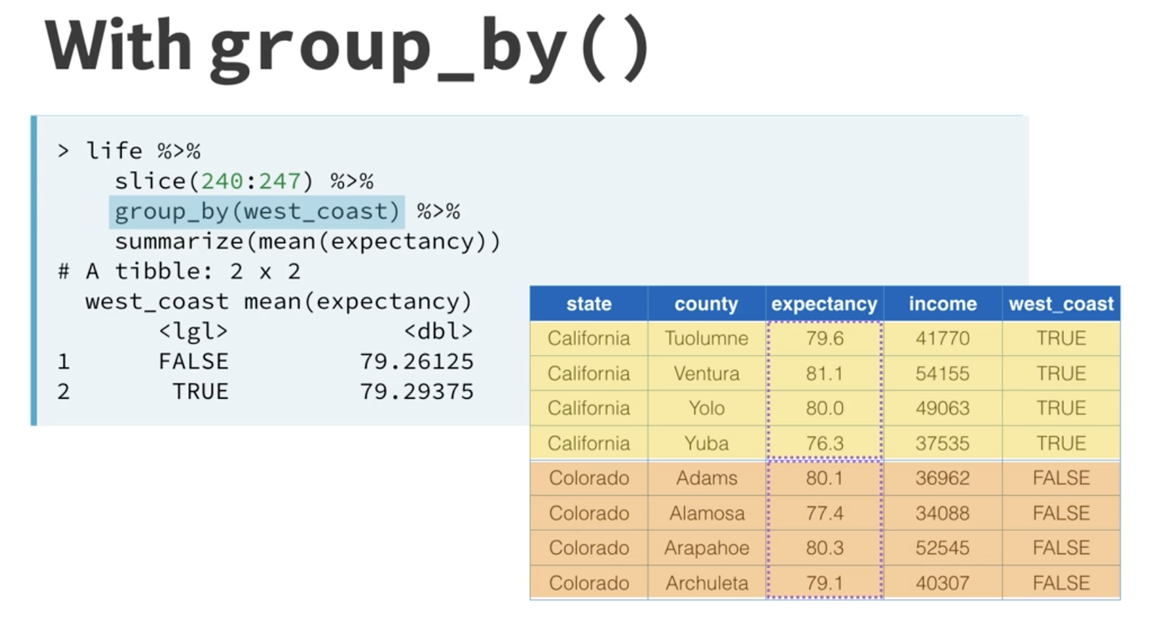

**2.Measures of variability:**

* Variability: How much the data is spread out form the center.
* say, we choose the center to be the mean. and then, we quantify variability of each observation by finding the difference of it from the mean. Now, add all the differences.

**We get this value in the negative exponents.** So, we square the differences and them.

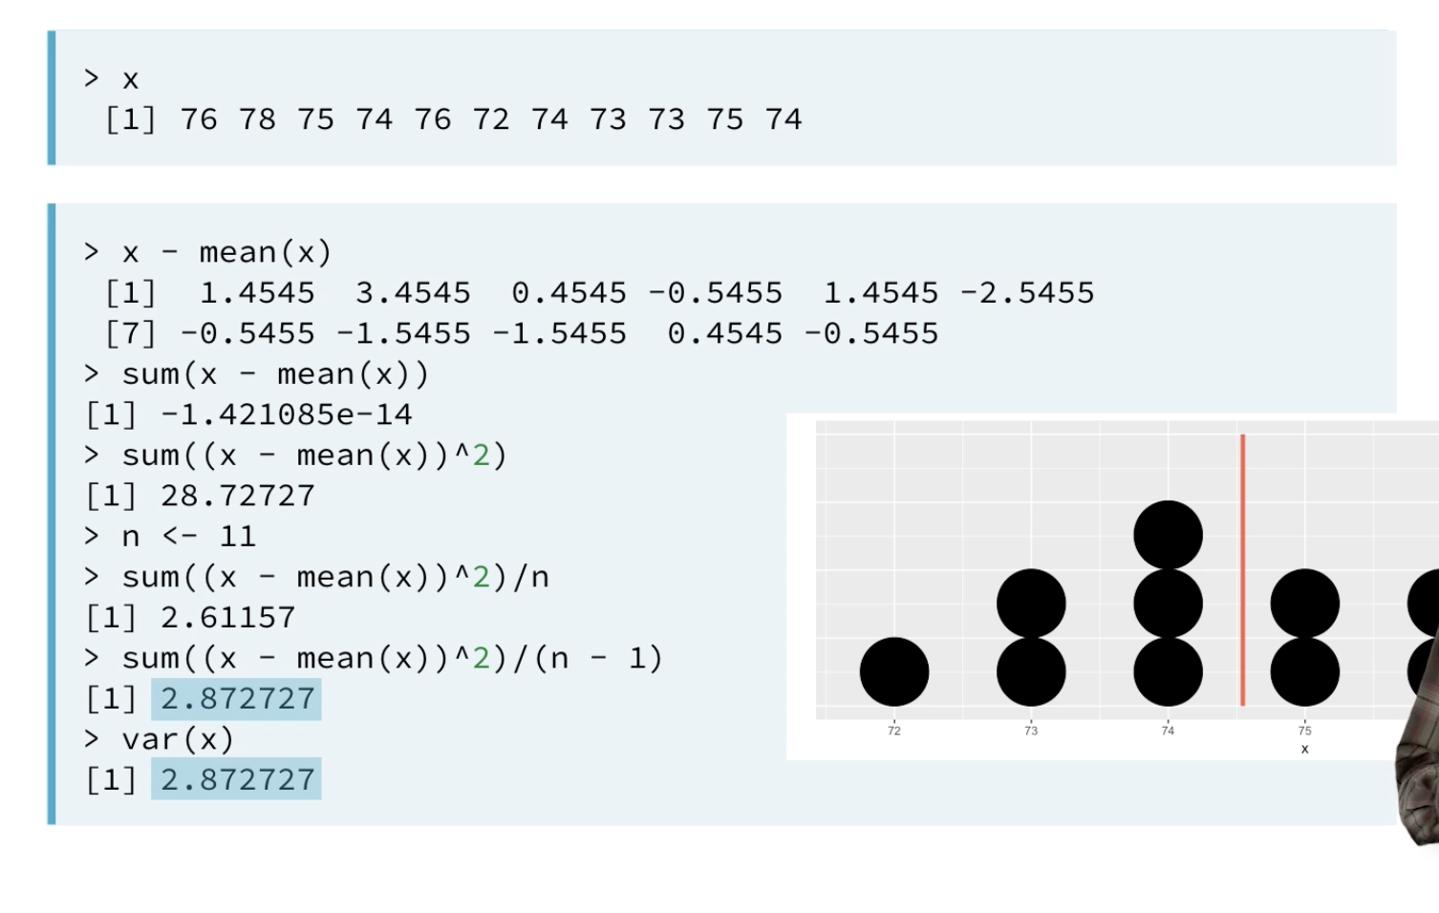

* This sum of squared differences has a drawback- **it increases to huge numbers when we increase the number of observations.** You can fix this by dividing this sum by the number of observations.
* **Dividing it by n-1 instead of n: is what is called *“sample variance”.*** In R, this is all summed up using var() function.

**STANDARD DEVIATION**

* *Square root of the variance* is the “Standard Deviation”.
* sd() function gets the standard deviation. Once computed, it’s value is in the same units of the original data.

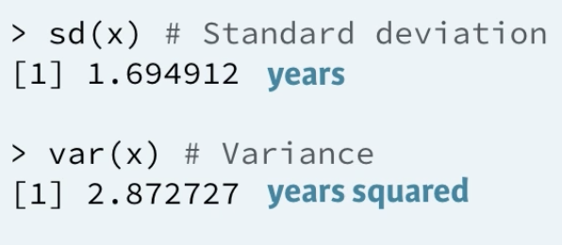

* **IQR(inter-quartile range)**

**[1st quartile – 3rd quartile] -** Height of the boxplot is exactly the IQR.

distance between the two numbers that cut off the middle 50% of the data. IQR() can be used or can be calculated manually.

summary() can be used for finding quartile ranges.

**Choice of spread measure**

The choice of measure for spread can dramatically impact how variable we consider our data to be, so it is important that you consider the shape of the distribution before deciding on the measure.

Example:

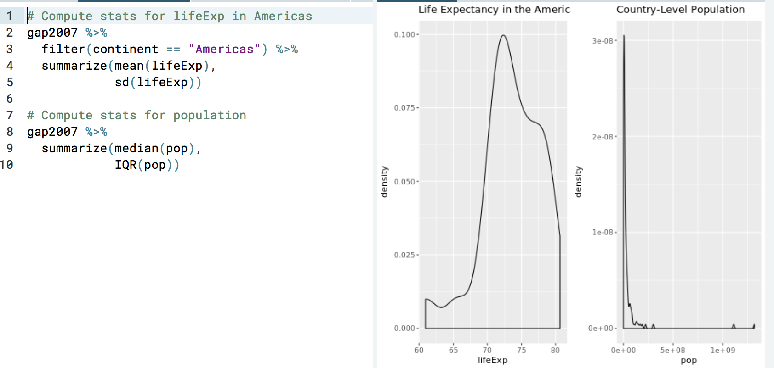

The above example clearly shows that for the first graph, we should choose measures like mean and standard deviation. **(It is more widely spread)**

and for the second one, the measures to be chosen should be mode, median, IQR. **(it is less widely spread- “huge portion concentrated in a small area”)**

1. **Shape:**

Described in terms of modality and skew.

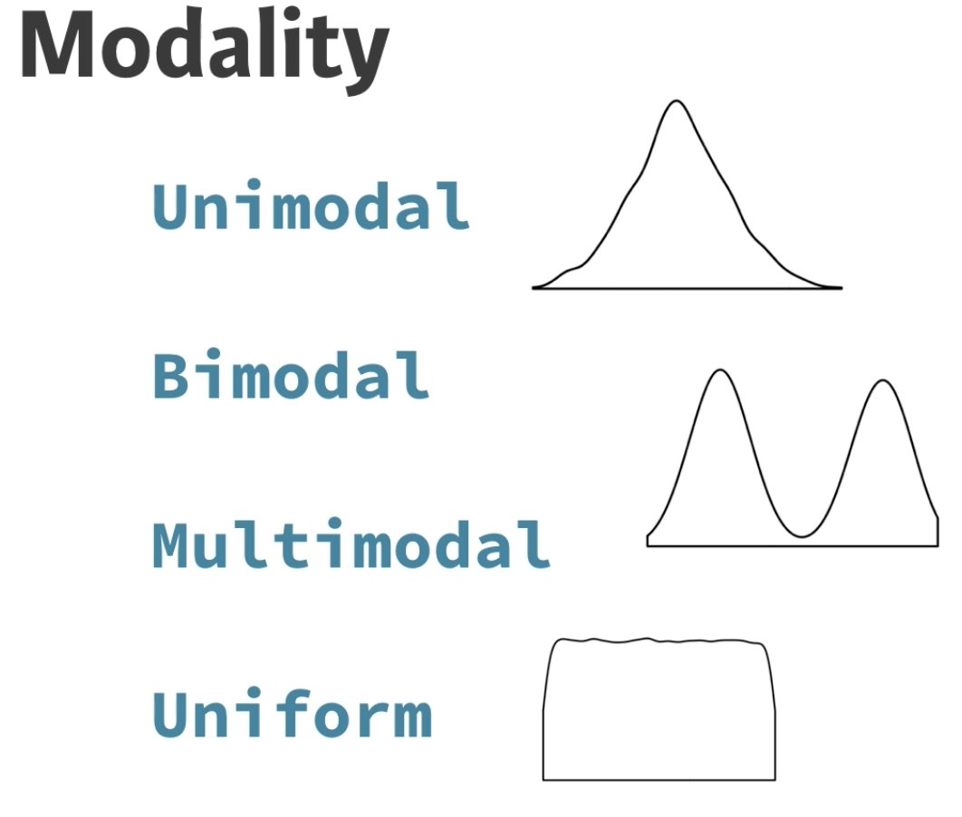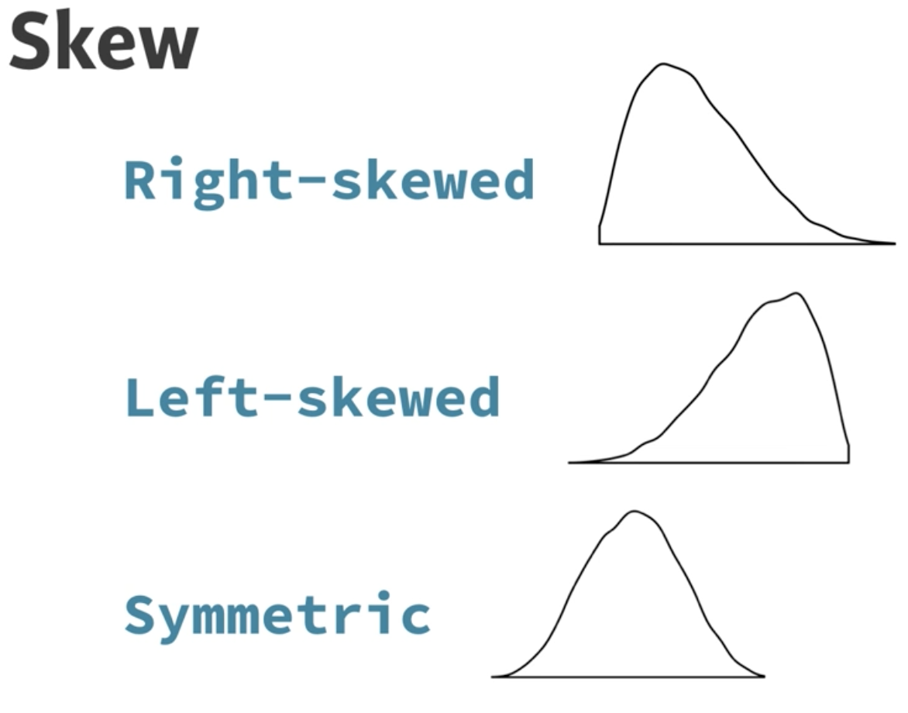

Highly skewed distributions can make it very difficult to learn anything from a visualization. Transformations can be helpful in revealing the more subtle structure.

Example:

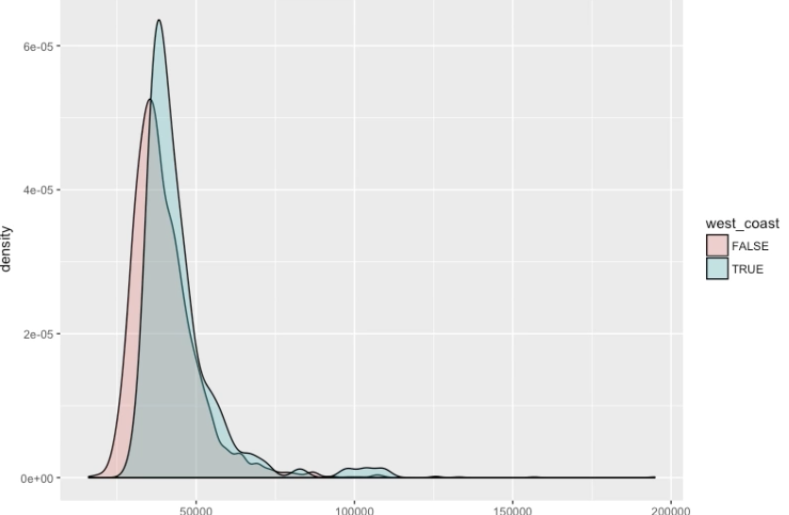

The above graphs are both **unimodal** and heavily **right-skewed.**

**Transformations can be applied to such kind of skewed distributions.**

We can apply **log transformation** or a **square root transformation** to spread out the values to see what’s going on(for easy interpretation of data).

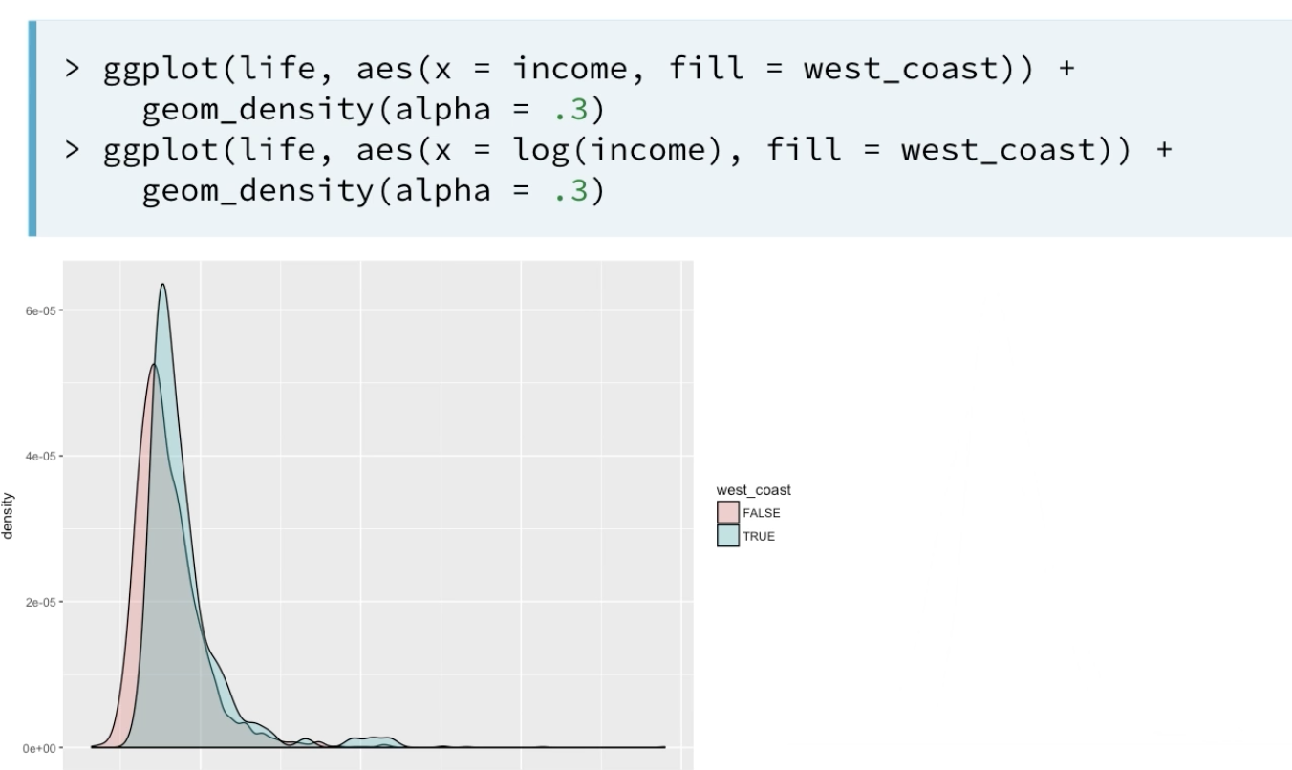

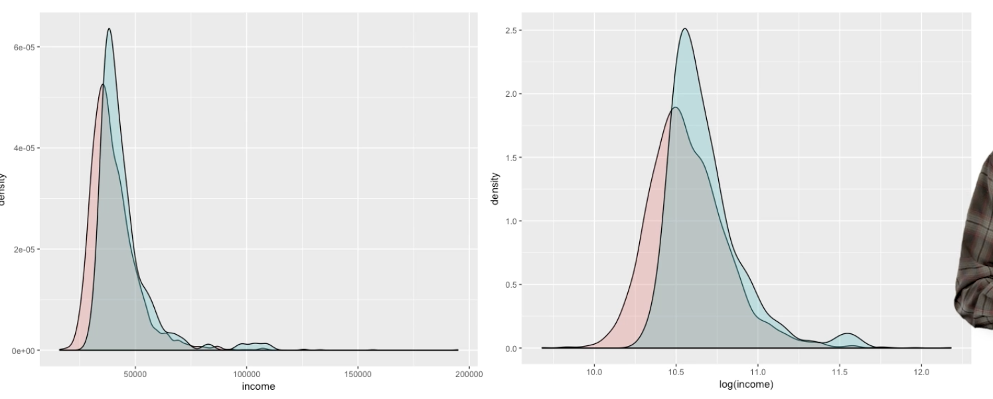

The result of log transformation is easier to interpret. We can make a conclusion that, the income of blue region is higher compared to the red region. And, very small mode of high value income distributions is not present in the red region.

1. **Outliers:**

Often useful to consider outliers separately form the rest of the data.

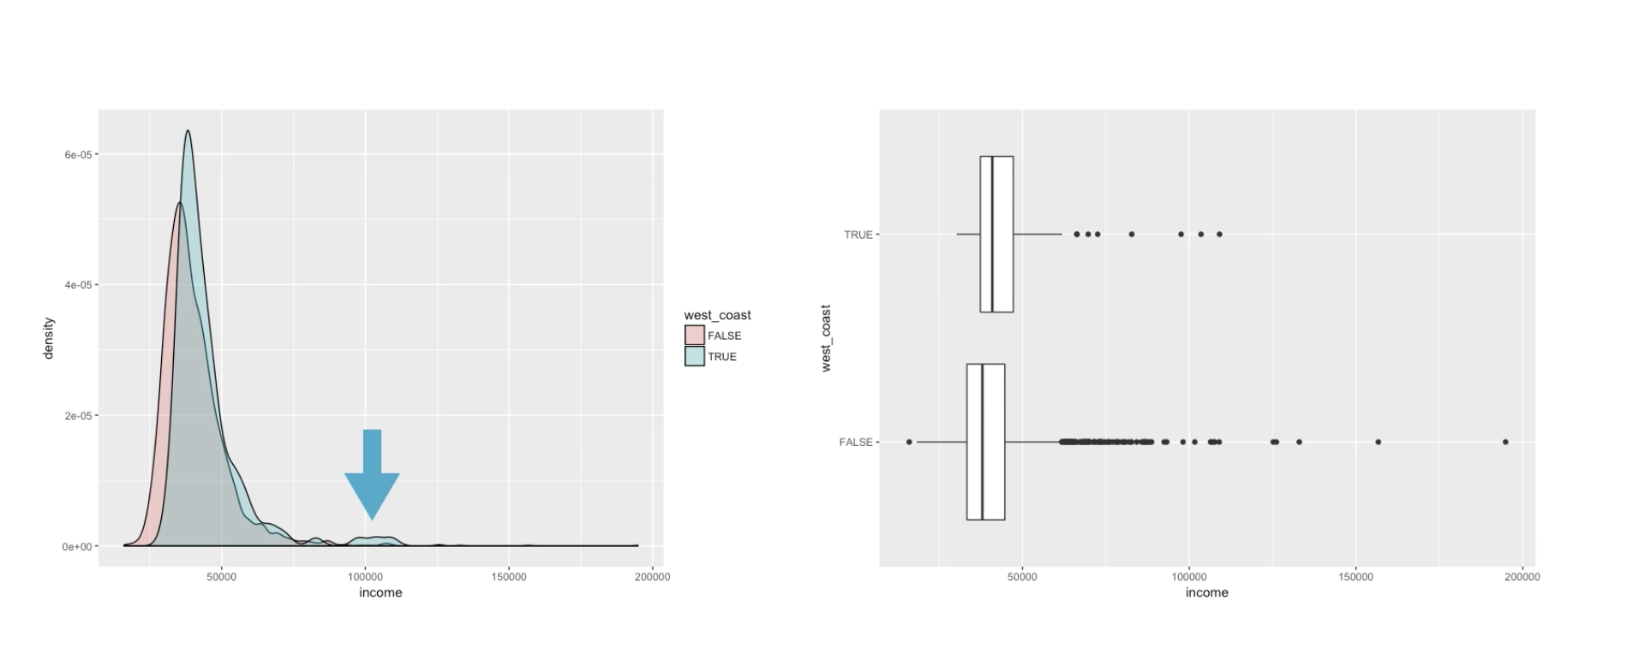

**Sample code:**

# Filter for Asia, add column indicating outliers

gap_asia <- gap2007 %>%

filter(continent == "Asia") %>%

mutate(is_outlier = lifeExp < 50)

# Remove outliers, create box plot of lifeExp

gap_asia %>%

filter(!is_outlier) %>%

ggplot(aes(x = 1, y = lifeExp)) +

geom_boxplot()

Example 2:

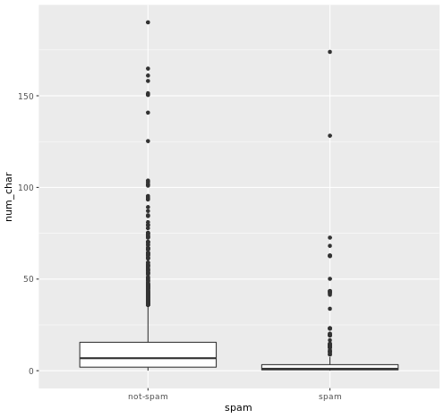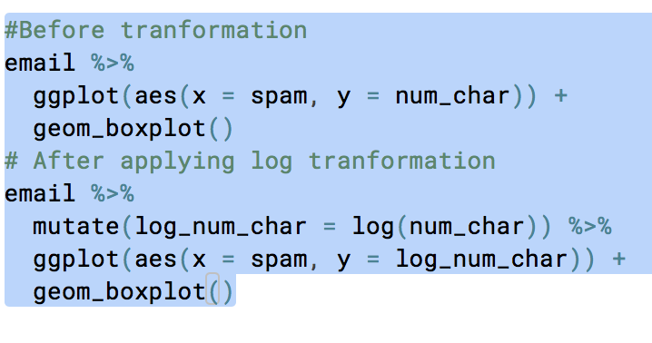

Initially, plot was like this.

After applying log transform, we get it like this:

